

Practices for Secure Software Report

Table of Contents
Document Revision History 3
Client 3
Instructions 3
Developer 4
1. Algorithm Cipher 4
2. Certificate Generation 4
3. Deploy Cipher 4
4. Secure Communications 4
5. Secondary Testing 4
6. Functional Testing 4
7. Summary 4
8. Industry Standard Best Practices 4

Document Revision History

Version | Date | Author | Comments
1.0 | 10/18/2026 | Jacob Truesdale | Student ID: 2714774

Client



Instructions

Submit this completed practices for secure software report. Replace the bracketed text with the relevant information. You must document your process for writing secure communications and refactoring code that complies with software security testing protocols.

- Respond to the steps outlined below and include your findings.
- Respond using your own words. You may also choose to include images or supporting materials. If you include them, make certain to insert them in all the relevant locations in the document.
- Refer to the Project Two Guidelines and Rubric for more detailed instructions about each section of the template.

Developer
Jacob Truesdale

Algorithm Cipher

SHA-256

SHA-256 is an industry standard for hash checksums. It is secure since hash collisions have a 1 in 2^256 chance of occurring. SHA-256 is not a decryptable encryption algorithm, so it does not make sense to use for a communication cipher. Instead, it is used to confirm that messages are correct when generated.

Provide a brief, high-level overview of the encryption algorithm cipher.
SHA-256 takes a list of 1s and 0s of any length, and converts them to a seemingly random list of 256 1s and 0s. This is a one way process, sort of like taking a number mod 50. If I saw that x mod 50 = 27, there’s no way to know what x was. SHA-256 is unreversable, and it is sensitive to the original list, so “abc” and “abd“ have vastly different SHA-256 results. There is mathematically no way to predict what a hash will look like without just running the algorithm.

Discuss the hash functions and bit levels of the cipher.
SHA-256 pads any string with a 1 followed by enough zeros so that [pad] + [string you want to hash] = 512 * k, where k is some number. Then it breaks down each of the k number of 512-bit blocks into 8 32-bit sections. It then performs logical operators, like xor, and, or, etc. to them over 64 rounds, combined with constants that reliably produce pseudorandom outputs. The k blocks are then combined with an xor operation so that there are only 8 32-bits left. Those are then concatenated to form a single 256-bit number, which is the hash. These values are not reversible, which produces a determined, one-way number. So it is easy to know if any bits have changed to an output file.

Explain the use of random numbers, symmetric versus non-symmetric keys, and so on.
Random numbers are impossible to create on computers, since computers are determined machines. So, Java, and many other languages use difficult to reproduce ways of generating a seed value to start a pseudorandom number generation algorithm. Java may use the system clock, or it may create a number from the 1’s and 0s stored in various locations in RAM, which change so quickly that it is unlikely to know what those RAM address values were when Java created the number. These random looking numbers are used to hide secrets, while still allowing us to communicate our secrets.

Symmetric key systems use numbers that the two communicating parties can agree on without a third party being able to figure out what the number agreed on was. These allow for easy communication since the cypher text can be any random string, because any rule for encryption can be used. A string of AAAAAAAAAAAAAAAAAAAAAAAAAAA is a viable cipher text under countless rules, because we can assign meaning to anything. Symmetric keys need to be generated often, so that no security breach compromises all past messages. They are fast when implemented but slow to actually start implementing since multiple messages need to go back and forth before real communication can begin. Non-Symmetric key systems, like RSA, are faster than Symmetric key systems, and they allow for messages to be sent where I know your public key, which is sort of like a blueprint for a padlock, that doesn’t reveal how a lock actually opens. So I can send you anything, and know that you will be the only one to be able to open it. These are quick to implement but they are unsecure when broken. If someone is able to find out your private key, then all messages are broken. So the best systems use a combination of the two. We use the non-symmetric keys to generate symmetric keys so we can communicate quickly for this single conversation.

Describe the history and current state of encryption algorithms
Encryption algorithms have been used throughout history to hide information. Caesar shift ciphers were among the first to be used. Oftentimes wax seal rings were used to show that a message had been unopened by anyone earlier, since the wax would have to be melted to make it stick to the paper, which destroys the image on the seal. This was the first form of a public key system, where the owner, usually a lord, would sign with his private key, and it would be clear that he had sent the message. As computers became more powerful, Euler’s work became more important, specifically facts about prime numbers that he believed were minor interests. Those became the backbone of modern cryptography in computers because it creates public and private key pairs. In modern times, these are under threat by the potential of quantum computers, which can very quickly find key pairs. So other methods are being searched for. One quantum computer safe method is the LCS35 Time-Lock Puzzle created in 1996 by Ron Rivest, Adi Shamir, and David A. Wagner. This allows us to very quickly create encrypted messages, and we can define the exact amount of time required to break it. Because the cipher is sequential to break, no amount of computing can solve it unless it works in sequential order, you could have all the computing power in the universe, and you would still not be able to crack the cipher until you have gone through each step.

Certificate Generation
Insert a screenshot below of the CER file.

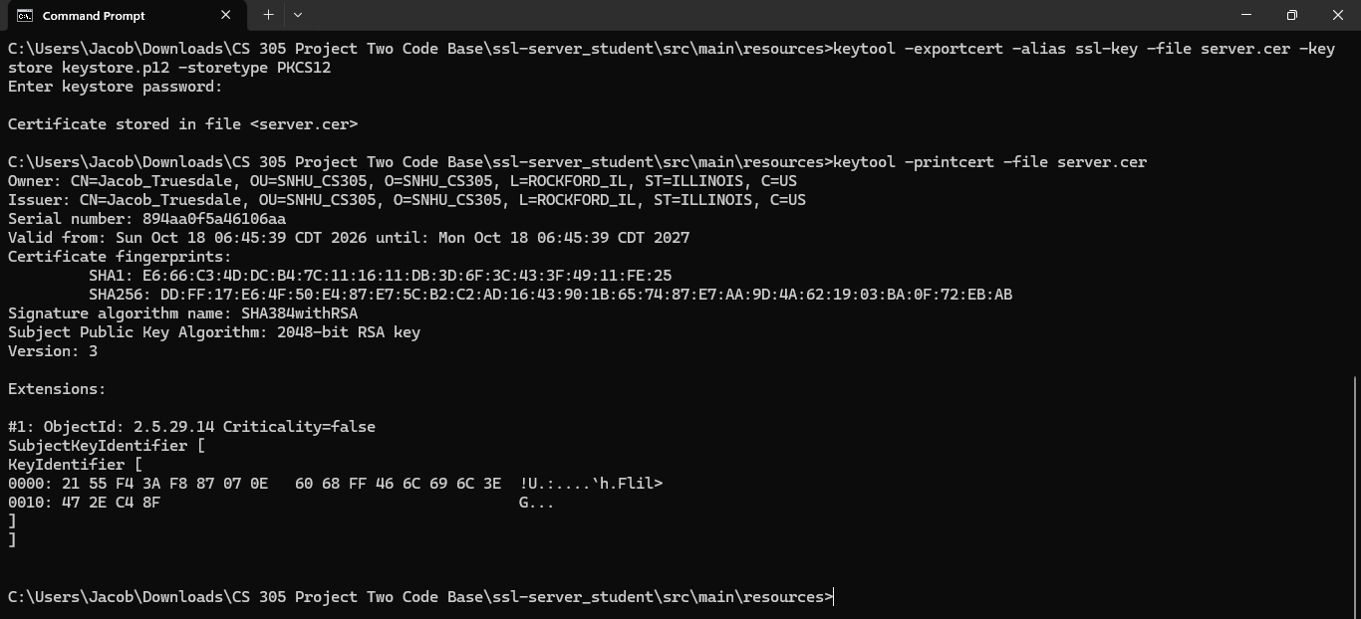

Deploy Cipher
Insert a screenshot below of the checksum verification.
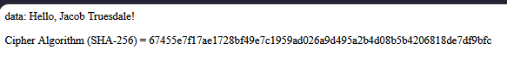
From “https://emn178.github.io/online-tools/sha256.html” the SHA-256 cipher of
Hello, Jacob Truesdale!
is
67455e7f17ae1728bf49e7c1959ad026a9d495a2b4d08b5b4206818de7df9bfc

Secure Communications
Insert a screenshot below of the web browser that shows a secure webpage.

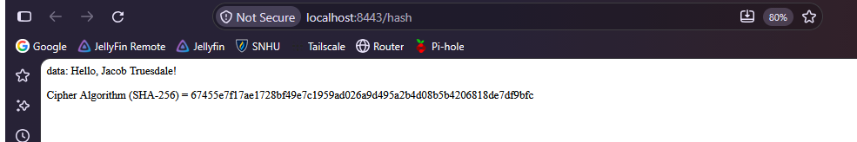

Secondary Testing
Insert screenshots below of the refactored code executed without errors and the dependency-check report.

This is the original dependency check without my refactored code:
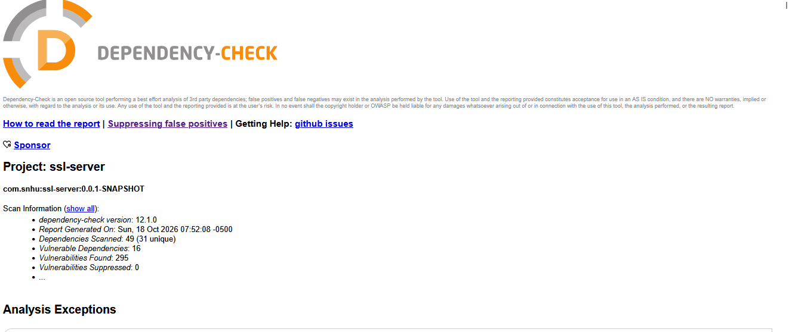

Here is the dependency check including my refactored code:
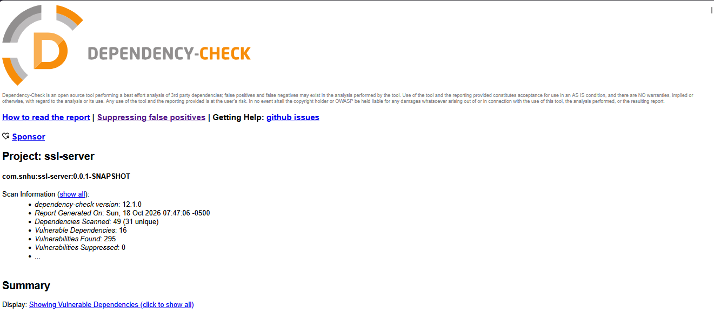

Functional Testing
Insert a screenshot below of the refactored code executed without errors.

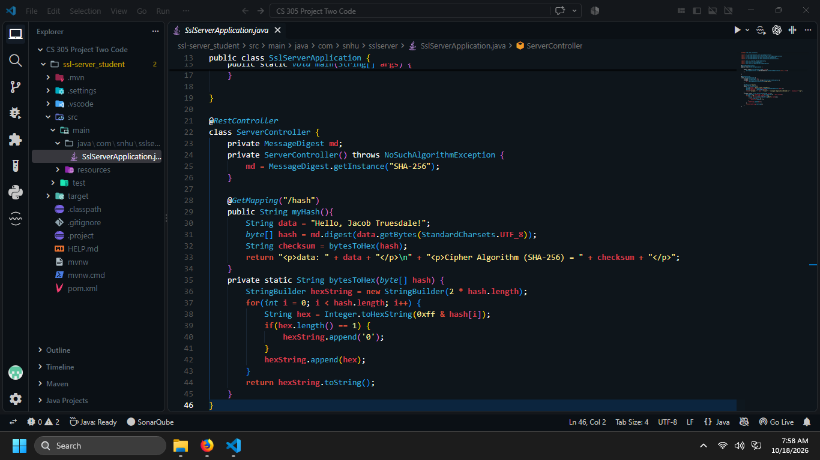

Summary

Refer to the vulnerability assessment process flow diagram in the Supporting Materials section. Highlight the areas of security that you addressed by refactoring the code.
By including SHA-256 into the code, we can ensure that the client application knows that the message sent was the one we intended to send. This is important to prevent different attacks because it confirms our intentions were not altered. This is specifically the “secure api interactions” section of the flow diagram. The next step would be to include a communication process with the client application. We can use RSA and SHA-256 to create a symmetric key system that confirms that our message was received properly, then use the symmetric key system along with SHA-256 to communicate with each other. We can even make our SHA-256 strings public, which means that we are safe from man-in-the-middle attacks, since they cannot change our messages.

Discuss your process for adding layers of security to the software application.
My process was to start by writing my message code, then adding in the SHA-256 hash function. Since this is on a server, it is private. My next step would be to look at the client side, and have them run the same hash function to confirm that what was sent by the server matches their SHA-256 of the message.

Industry Standard Best Practices

Explain how you used industry standard best practices to maintain the software application’s existing security.
Explain the value of applying industry standard best practices for secure coding to the company’s overall well-being.

I added the secured RestController to act as my RESTful API hash algorithm. The Server Controller uses SHA-256, the industry standard cipher, since hash collisions are so rare. I would suggest running dependency checks often, since NIST updates their list of vulnerabilities often. This helps companies keep their sensitive data secure. Also, making sure that pom.xml is up to date is key. The pom.xml in this file used version 5.3.0 of the dependency check, which I updated to 12.1.0. This should be done regularly to ensure security.

